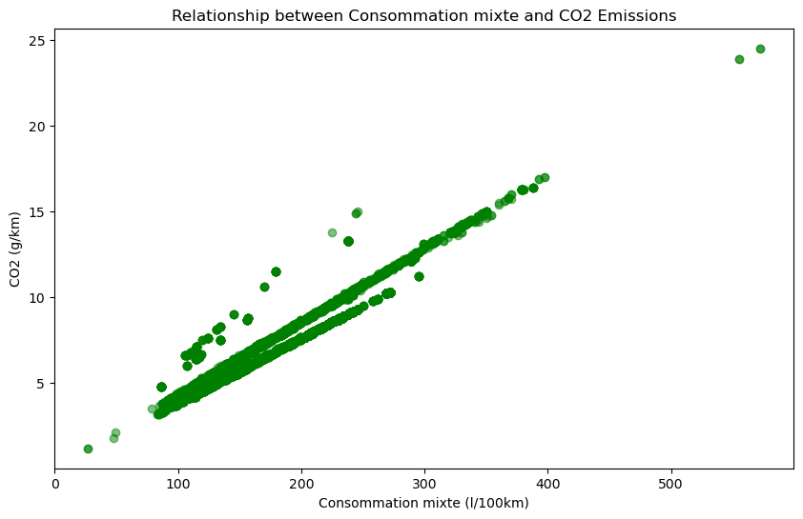

Abbildung 1: Relationship between Consomation Mixte and Co2 Emissions

The scatterplot illustrates a clear positive correlation between fuel consumption ('Consommation mixte') and CO2 emissions. The main trendline slopes from the bottom left to the top right, indicating that vehicles with higher fuel consumption tend to have higher CO2 emissions.

There are two additional lines observed at approximately 70 l/100 km. One line runs below the main trendline up to around 300 l/100 km, while the other runs at the same height but above the main trendline. These additional lines suggest potential subgroups or distinct characteristics within the data:

* Below the main line up to around 300 l/100 km: Vehicles in this range may possess specific attributes leading to lower CO2 emissions despite higher fuel consumption.
* Above the main line up to around 300 l/100 km: Vehicles in this range may have characteristics resulting in higher CO2 emissions, even with relatively lower fuel consumption.

Further exploration and subgroup analysis could provide insights into the unique features influencing CO2 emissions within these fuel consumption ranges.

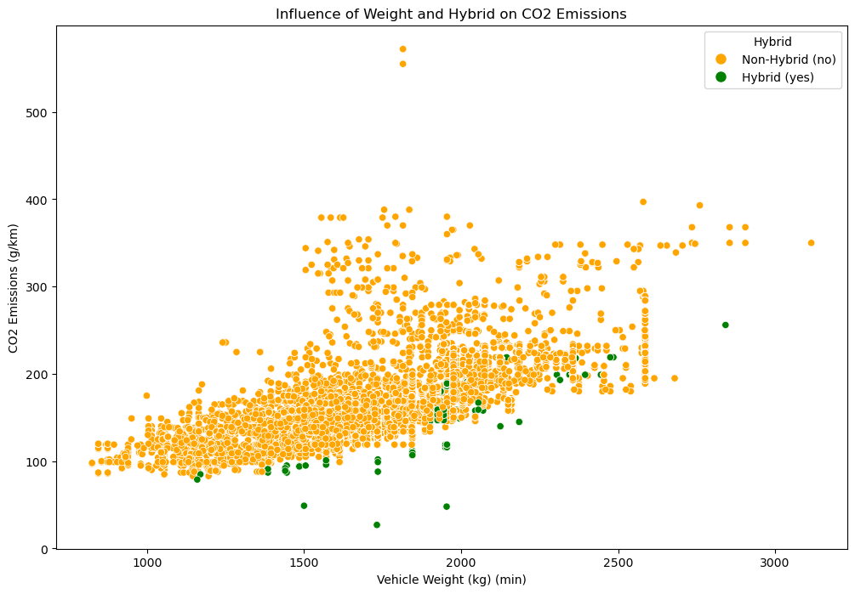

Abbildung 2:Influence of weight and Hybrid on Co2 Emmissions

Weight and Hybrid Influence on CO2 Emissions:

* For vehicles with a weight below approximately 1800 kg (minimum weight), the green points (Hybrid vehicles) seem to have generally lower CO2 emissions compared to the orange points (Non-Hybrid vehicles). This could suggest that Hybrid vehicles may be more efficient in terms of CO2 emissions at lighter weights.
* From a weight of about 1800 kg onwards, there appears to be a mixing of green and orange points, indicating that the influence of vehicle weight on CO2 emissions becomes more similar between Hybrid and Non-Hybrid vehicles.

It would be interesting to conduct additional analyses, such as dividing the data into weight ranges and examining average CO2 emissions in these ranges. This could help further explore the relationship between weight, hybrid properties, and CO2 emissions.